“BOSCH’S DAMNATION”
(Carol Reed Mystery # 10)

WALKTHROUGH
Len Green lengreen@hotmail.com
26th March 2014

PREFACE

***** Locations that are added to the map are written in blue.

***** Items that are added to the inventory are written in green.

***** Items that are used are written in purple.

***** Some lines that are spoken by Carol are quoted in the walkthrough, for easier orientation. They are written in pink.

***** General comments are written in brown.

The Walkthrough

WINTER

Home (1st visit)
The game starts at Carol’s home during the winter.
Turn right twice. There is a telephone lying on a chair. It can be viewed in close-up.
Pick up the telephone.
Enter the hallway. Carol receives a text message. George the cleaner appears on the map.
Enter the living room, and look at the notebook computer close to the window.

George the cleaner (1st visit)
Talk to George. And exhaust all dialogs.
The Stierngranat family’s house appears on the map.

The Stierngranat family’s house (1st visit)

The ground floor
Enter the first room to the left on the ground floor. Find the box on the fireplace and open it. Take the key from box.
Find the long corridor in the middle of the ground floor. At the end of it (There is a vintage looking telephone at the end!), see a locked door on the right. Use the key from box to open it.
Open the cabinet to the right in the small kitchen. Take the needle-nose pliers.
Exit the small kitchen.
You are facing the door to a walk-in closet (i.e. opposite the door to the small kitchen). Look at the shelf. Carol says: ”I wish I could reach that upper shelf. The rest is only laundry”. A gearwheel hotspot appears under the shelf.

The upper floor
Climb the stairs in the hallway to get to the upper floor.
In the first room, find the artifact on the shelf. Look at it in close-up. Carol says ”There’s a metal object in there”. Try to grab it, but Carol’s hand is too big. Use the needle-nose pliers to reach the hidden key and take it.
There are two nurseries on the same floor. Find the portable decorated children’s wardrobe in one of them. Open it, and pick up the mini flashlight.
The ground floor
Go downstairs again.
The hidden key opens the door to the small storage room close to the hallway.
Use the mini flashlight to see what’s in the storage room.
Grab the wallet from the storage room, and take the password note (See Graphic #1).

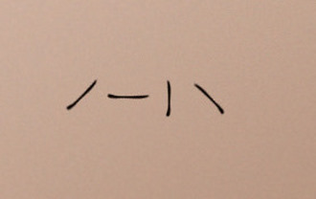
Graphic #1

The upper floor
Again go up the stairs to the upper floor.
Close to the shelf with the artifact, there is a door leading to the attic.
The password note from the wallet contains a clue on how to open that door.

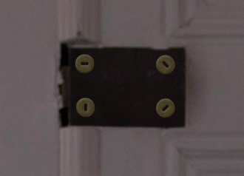
Graphic #2

If you have difficulty solving this puzzle, please read on:-
Study the password note as illustrated in Graphic #1.
Taking the order of the symbols from left to right, click the corresponding switches in that order.
If you still have problems solving this puzzle, please look at the graphic #2, and:-
Press the 4 switches in the following order:- Bottom right; Top left; Bottom left; Top right.

The attic
After entering the attic, turn right and pick up the stepladder.
Enter the small storage room: Pick up the symbols from storage room from the cardboard box.
The ground floor
Go back to the walk-in closet to the left at the end of the long corridor. Use the stepladder to reach the shelf.
Take the metal box. Study the drawing in inventory (See Graphic #3).

. 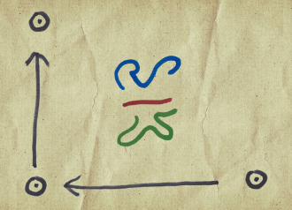
Graphic #3
The symbols etc. from the storage room in the attic are a clue to opening the box.

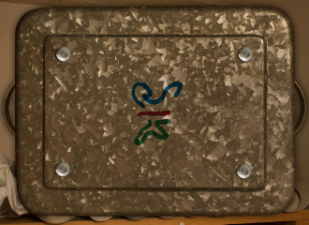
Graphic #4
If you have trouble solving this puzzle:-
Scrutinize Graphic #3. Pay attention to the 3 symbols in the middle, the 3 buttons surrounding them and the 3 long arrows.
If that is not sufficient:-
Press the top right button once, so that the 3 colours of the symbols on the lid of the box match the colours on the drawing i.e. from top to bottom… blue; red; green. Then press the buttons in the following order: Bottom right, bottom left, top left.
Examine the contents of the metal box by reading the birthday card which has highly coloured flowers on one side and birthday greetings from Carin to Martin on the reverse side.

George the cleaner (2nd visit)
Talk to George again and complete all conversation.
Martin’s room appears on the map.

Martin’s room (1st visit)
View the fruit box to the right of the bed – and open the envelope in it. Carol says: ”The Blood Falls? Maybe I can ask Stina about that”. Stina appears on the map.

Stina (1st visit)
Talk to Stina and conclude all dialogs.
The Blood Falls (a small waterfall attraction) appears on the map.

The Blood Falls (1st visit)
Walk to the very end of the area and go through the squeaky gate, until you reach a rusty tunnel beside the waterfall. Carol says: ”I don’t see any colours here”.
Pick up the USB flash memory stick lying on the bench beneath the stairs in the tunnel. Carol says ”It’s a USB flash memory stick. It must have fallen out from somebody’s pocket”.

Home (2nd visit)
It is now night time.
Find the notebook computer in the living room and insert the USB flash memory stick in it. Read what’s on the computer screen. Carol says ”It looks like I will have to go there at night”.
Exit Carol’s apartment to enter the nighttime map.

The Blood Falls (2nd visit)
Walk close to the waterfall and remember the bright colours! reflected from the water there.
Carol automatically picks up her cell-phone. Left click on the phone to take a picture of the waterfall, and get a photo of The Blood Falls in inventory.


Graphic #5

Home (3rd visit)
Carol is tired now, and wants to sleep. Enter the bedroom and go to bed.

Martin’s room (2nd visit)
Close to the window, there is a wooden box under Martin’s bed. It has four buttons in different colours. Open the box.

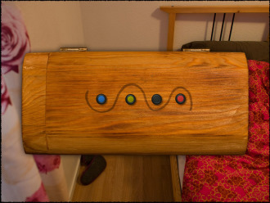
Graphic #6
If you find this difficult take a good look at the colours of the waterfall – if you don’t remember them refer to Graphic #5.
Press the 4 coloured buttons in the same order that you saw the colours of the waterfall (from left to right) i.e. Black; Blue; Red; Yellow.
There is a contract addressed to George Pamper in the box. Read it and then close the box.
George sends a text message to Carol. It seems that the family is perfectly safe after all.
_________________________

SUMMER

Carol’s allotment (1st visit)
After the cutscene, Carol is lying in her hammock contemplating the sky. Leave the hammock using the back-arrow.
Look at the hammock in close-up. Pick up the allotment key.
Try the allotment key in the lock to the small house on the allotment. The key gets stuck in the lock. Carol says ”I think it needs some lubrication”. A gearwheel hotspot appears on the stuck key.

Stina (2nd visit)
Talk to Stina, and read the newspaper article, which goes into inventory.
The barn appears on the map.

The barn (1st visit)
Find the small house behind the barn. Pick up the rake.
Enter the barn. At the entrance, pick up the fingerprint powder to the right of the old broken down cart.
Find the door to the inner room. Notice the gearwheel icon to the right of that door. Enter the inner room.
Take the long metal ladder, which is lying on some straw in the inner room.
Prop the long metal ladder up against the wall to the right of the door leading to the inner room.
Look at the brown rectangular object on the floor in the hayloft. Try to take it. Carol says ”It’s too far away. And I don’t want to walk out there”.
Try to get the brown object with the rake. The object falls through the hole in the floor.
Go down from the hayloft, and enter the inner room again. The brown object lies in a stall to the right. Look at it in close-up. It is an old-style digital watch.
The Malte Stierngranat museum appears on the map.
When Carol leaves the barn area, she says ”Maybe I should check with George if Martin’s room still is unoccupied”. (This does not happen if the fingerprint powder hasn’t been picked up).
George the cleaner appears on the map again.

The Malte Stierngranat Museum (1st visit)
The museum has two floors. In the very small hallway, from which we enter the museum, two doors are locked: One leading to a room which is ;Being redecorated’, and one with a padlock on it.
Enter the chapel from the hallway. Read the information about Malte on the several sheets of paper lying on a table.
Climb the stairs in the hallway to get to the upper floor.
Enter the first room to the left. Pick up the brochure lying on a chest and read it.
In the same room, there is a book behind an open door. Look at it in close-up and read it.
The pyramid appears on the map.

The pyramid (1st visit)
Take a good look at the exterior of the pyramid and its surroundings. The pyramid can’t be entered yet.

George the cleaner (3rd visit)
Talk to George, and read the letter he shows Carol.
Martin’s room appears on the map again.

Martin’s room (3rd visit)
Open the wardrobe, and look in the pockets of the dark blue jacket.
Monica appears on the map.

Monica (1st visit)
Talk to Monica and complete all topics.
The Church Museum appears on the map.

The Church Museum (1st visit)
Find the code lock to the left of the door to the Church Museum. Look at it in close-up.
Note that four digits are considerably dirtier than the rest.
The dirtier digits are:- 1; 6; 9; 0 .The door has to be opened by trying possible combinations of these four digits. There are 24 different combinations altogether. You have to try each one until you reach the correct one!!
The code is 6910.
Enter the museum. There is a die on a shelf at the back of the front desk, near the entrance. Pick up the die, and Carol will take a photo of the die’s six faces,
The die goes into inventory.

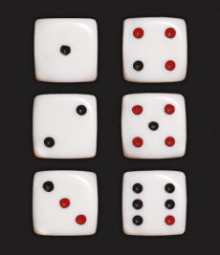
Graphic #7

In the small room, there is a large picture of an old photo, just above the sofa-set. Look at it in close up, and read the text. The School Museum appears on the map.
In the church room, look at the Hieronymus Bosch painting on the left wall, and the psalm board right of the altar. Read the text about Malte under the psalm board.

The School Museum (1st visit)
There is a code lock on the door to the School Museum. Look at it in close-up. You need to enter the correct code in order to get into the School Museum.

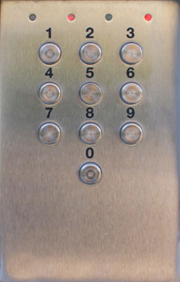
Graphic #8

If you have trouble entering the Church Museum read further!
Look in inventory at the photo of the die’s six faces. First note the 4 faces (only) which have red dots on them. There is one red dot on the number-6 face of the die and hence the 1st digit (from the left) of the code is 6. There are two red dots on the number-3 face of the die and hence the 2nd digit (from the left) of the code is 3. In a similar way, 3 red dots leads to the 3rd digit (from the left) of the code which is 4 – and finally , 4 red dots indicates the 4th and last digit (from the left) of the code which is therefore 5.
Hence the complete code is 6345,

In the School Museum, enter the first door to the left, and go through the corridor. In the kitchenette, find the wastepaper basket, and look at it in close-up. Pick up the postcard, and turn it around. Martin mentions on the postcard that Carin has a studio. Maybe George knows something about that?

George the cleaner (1st visit)
Talk to George and exhaust all dialogs.
Carin’s studio appears on the map.

Carin’s studio (1st visit)
The door to Carin’s small studio is to the left in the corridor.
At the first, white shelf to the left, there are some tools. Look at the red hole punch in close up, and pick it up.
There is also a shelf on the right wall, holding books and binders. Look at it in close-up, and grab the newspaper article.
The Sonic Forge appears on the map.

The Sonic Forge (1st visit)
In the first, large room, take the oil from a wooden pallet close to the left wall.
Enter the first room to the left. Take the sound recorder from the table.
Go further into the building, and find the swing doors. Try to open them. Carol says ”It’s totally stuck”. A gearwheel icon appears on the swing doors.

Home (4th visit)
Open the door to the wardrobe in the hallway, and pick up a flashlight.
There is a tablet computer by the bed. Turn it on, and read about the Blood Falls.

The Malte Stierngranat Museum (2nd visit)
When the sound recorder has been picked up, and the sheets in the chapel viewed have been viewed together with the brochure on the upper floor in the Malte Stierngranat, the room that was previously locked for renovation on the ground floor is now open. Enter that room, and read the pamphlet lying on a chest to the left.
The Johansson Peak appears on the map.

The Johansson Peak (1st visit)

Walk up the 200 metre high stairs, and then turn to the left and follow the road. Before it turns to the right, look at the large painting at the left side of the road. Notice the smoke that leaks from the ground and the back of the gigantic Johansson sign.
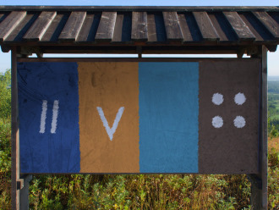
Graphic #9
Find two statues, one depicting a man and the other a woman. Pick up the brochure lying in front of the male statue. In close up, look at what Mikael Nyqvist is holding in his hand. It’s a magnetic card with four holes.
Find a small bench in the center of the area. Pick up the magnetic card lying in front of it. Note that it has three holes.
Use the hole punch on the magnetic card to punch a fourth hole in the card, and get a punched magnetic card.
Go to the ‘ornamental Ark’ at the centre of the area. In close up, view the front of the Ark. Use the punched magnetic card on the slot there.
In addition, a code must also be entered in order to open the Ark.
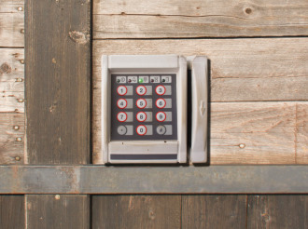
Graphic #10
We know from the brochure close to the statues that the painting at the beginning of the area provides a clue to this code.
The painting consisted of four vertical stripes-: One with two lines, one with a letter V, one with nothing in it at all, and one with four dots. The two vertical lines represent the number 2; the letter V the number 5, the empty stripe represents nothing (zero); and the four dots the number 4.
Thus the code is 2504.
After entering the Ark, look at the paintings on the walls. The Saint Maria Church appears on the map.

The Saint Maria Church (1st visit)
Pick up the pamphlet in the church porch and read it.
Jonas sends a text message, and he appears on the map.
Enter the church room. There is a choir room to the left in the middle of the church. Find the copy of the painting in that room, and examine it.
Find the sacristy, the room to the left of the altar. Read the folder on the table. Carol says ”I wonder where this car graveyard is?”.

Jonas (1st visit)
Talk to Jonas, and ask him about the car graveyard. (You have to have read the folder in the sacristy in the Saint Maria Church before you can ask him about the car graveyard).
The car graveyard appears on the map.

The car graveyard (1st visit)
After a few steps, Carol says ”I’m not suitably equipped to walk around in this mud”. It’s not possible to progress further here at this stage.

The allotment (2nd visit)
In the small house, use the oil on the key which is stuck in the lock.
Take the gum boots in the small house

The car graveyard (2nd visit)
After taking a couple of steps forward and in order to progress further in the mud, use the gum boots on the gear wheel icon.
Look at Sten’s car at the left side of the pathway. Carol says ”I recognize that car from the folder in the church”.
Find Sten’s extremely small house to the right side of the pathway, and enter it.
Pick up the crowbar.
There is a van close to the blue bus neat the end of the area. Look in its back seat in close-up, and pick up the hammer.
Find Sten’s work shed at the end of the area. Peek through the left door, and take the bicycle tire.
Enter the work shed through the right door. Examine the objects on the bench to the right. Lift the pouch, and grab the knife.

The Sonic Forge (2nd visit)
The swing doors at the end of the factory area can now be opened with the crowbar.
In the room behind the swing doors, lift the box with cables from the floor. Carol says ”I think we have an audio cable here”. Take the audio cable.
Enter the other room behind the swing doors. To the left, there is a filing cabinet with an open drawer containing a blueprint. Lift the blueprint. Emhart Zurich appears on the map.

Home (5th visit)
It is night time when Carol arrives home after having picked up the audio cable.
Go to the bedroom. Read the article on the tablet computer by the bed.
Carol turns to the bed and says ”This surely looks inviting now”. After having finished with the tablet computer, go to bed.
Carol wakes up the following morning.
Combine the audio recorder with the audio cable and get an audio recorder with cable.
Go to the living room and use the audio recorder with cable on the notebook computer. We hear some loud noises that Martin had deliberately recorded (for the computer game he was developing) in the Sound Forge factory, followed by a message he left to himself: Note to self: “It just struck me that the perfect hiding place would be that strange space behind my wardrobe”.

Martin’s room (4th visit)
Open the wardrobe in Martin’s room again. Move the clothes. Carol says ”A hatch! How could I miss that?”.
The left wooden peg can be loosened by hand. Look at the right wooden peg. Carol says ”I need more than my hands for this”. A hand icon appears on the right wooden peg.
Use the hammer to loosen the right wooden peg.
Look at the dark space that is revealed behind the hatch. This must be the hiding place Martin was talking about on the audio recorder. Carol says “I won’t go in there without some light”.
Use the flashlight on the dark space, and enter it.
Turn to the left, and find the wooden box above a small wooden ladder. Look at it in close up. It can’t be opened yet.

Emhart Zurich (1st visit)
Talk to Emhart Zurich and complete all dialogs.
Radiot’s cabin appears on the map.

Radiot’s cabin (1st visit)
Open the door to the house and a hefty bearded man (“Mr. Bigge”) meets us.
Talk to him and exhaust all topics of conversation.
The sister’s house appears on the map.

The sister’s house (1st visit)
Find a curious sort of desk in the living room. Open its drawer, and pick up the key from sister’s house.
Find the kitchen, and open the door that leads outside. Use the key from sister’s house to open the shed.
Pick up the colourful note to the right in the shed and enter it into inventory.
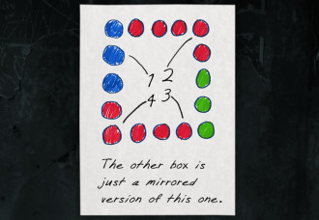
Graphic #11
Return to the house itself and take the stairs to the upper floor. The stairs are located opposite the main entrance. Find the bedroom. Look at the nightstand in close-up.
Lift the box from the nightstand and examine the inside of the lid.
By pressing the appropriate buttons, open the box.
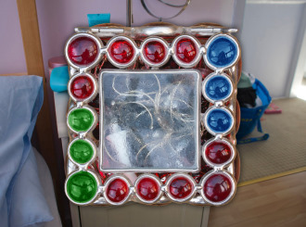
Graphic #12
You may have trouble with this puzzle – if so please read on:-
Actually what vou see in graphics 11 and 12 is NOT the top of the box itself but the mirror image of the box – it is what is known as ‘lateral inversion’ whereby everything on the right appears on the left and vice versa (but there is NO inversion from top to bottom).
Look carefully at graphic # 11 and click 4 buttons in order as marked on the graphic 11 in order from 1 thro’ 4. However don’t click the buttons as seen in graphic #12 but their mirror images as described above.
If that is not clear, click the buttons as follows…
{1) Right side second button down from the top.
{2} Top, first button on the left.
{3} Bottom; second button from the left.
{4} Bottom; fifth button from the left.
Take the key from the box – it is now in inventory.
Exit the house through the kitchen. The guest house, is immediately to the right of the house. Utilize the key from the box to open the guest house.
Get the list with instructions from the wastepaper basket in the guest house.

Radiot’s cabin (2nd visit)
Enter the cabin, and Carol automatically gives the list to the bearded man.
After a few words with him, the bearded man leaves, and we hear him close the door behind him.
Find the living room, and look at the small table by one of the windows. Lift the postcard and it goes into inventory – it is a drawing by Carin… examine it there – See graphic #13.
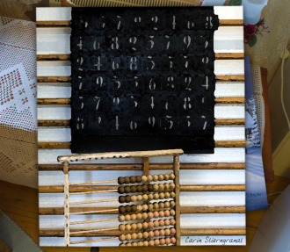
Graphic #13
Pick up the key from the mantelpiece which is situated to the left of the door leading to the kitchen.
Open the door beside the front door with the key from the mantelpiece. Climb the stairs.
Pick up the letter from distributor in front of the radio. Note the colours on the three triangles in the logotype for Martin’s gaming company – Graphic # 14.

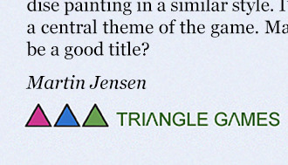

Graphic #14

Martin’s room (5th visit)

Enter Martin’s hiding place again. The wooden box can now be opened.

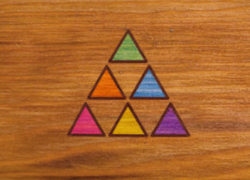

Graphic #15

Open the wooden box with the help of the colours on the logotype for Martin’s gaming company as seen in Graphic # 14.

They are pink, blue, and green in that order.

Pick up the key from Martin’s hiding place.

The Malte Stierngranat Museum (2nd visit)
The door with the padlock in the hallway can now be opened with the key from Martin’s hiding place.
Pick up the article on the shelf to the left.

The car graveyard (3rd visit)
Find Sten’s car on the left side of the pathway, and look at it in close-up. Use the knife to find the key from Sten Johansson’s car.

The pyramid (2nd visit)
Open the gate to the pyramid with the key from Sten Johansson’s car.
The inner door can’t be opened yet.

The School Museum (2nd visit)
Enter the second room to the left. Look at the board with numbers. Carol will take a photograph of it, which gives us the photo from the School Museum (Graphic #16) and which goes into inventory.
Find the box on the high shelf on the left wall in Carin’s studio. The lid resembles the board with numbers in the School Museum (See Graphic #17) but with four numbers replaced by asterisks.
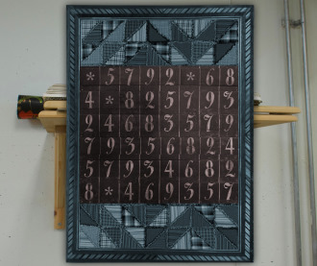
Graphic #16
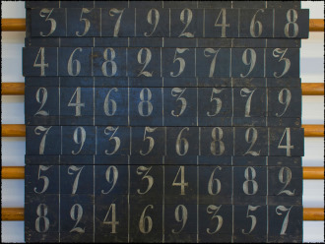
Graphic #17

Carin’s studio (2nd visit)

Open the box.

In order to solve this puzzle you have to examine carefully and compare Grapic #’s 13, 16, and 17.

First pay attention to the abacus on Graphic #13.

The abacus below the board on the drawing is a lead: The first row FROM THE TOP has 4 darker beads, the second has 6, the third has 2, and the fourth has 3.

This is a clue to the fact that the buttons we have to press on the lid of the box are 4, 6, 2 and 3 – but it does NOT in itself give us the order of pressing these 4 buttons.

This can be done simply by trial and error – but there are 24 combinations which may take quite a long time. But a much better way is available!

If we now examine and compare the positions of the asterisks on Graphic #16 with the actual numbers they replace on Graphic #17.

Remember the previous result from the abacus (i.e. in correct above determined order… 4, 6, 2, 3).

We see that the only number 4 which is replaced by an asterisk is on the top line and 6 places along from the left. Likewise the only number 6 which is replaced by an asterisk is on the second line down and two places along from the left. The only number 2 which is replaced by an asterisk is on the bottom line and two places along from the left. And finally, the only number 3 which is replaced by an asterisk is on the top line and on the very left side.

So you have to press on the buttons in

the following order:-

[1] Top line and 6 places along from the left.

[2] Second line down and two places along from the left.

[3] Bottom line and two places along from the left.

[4] Top line and on the very left side.

The Church Museum (2nd visit)
The poem by Malte (in red) is the key to the code to enter the pyramid. The poem refers to the Bosch painting (or, rather, the two halves of it). The five stanzas in the poem each reveal one number.
The answers to the first 3 stanzas can be found in the half in the church museum. It hangs on the left wall in the church room in the museum.
How many poor souls do we see
Inside the human tree?
Five persons can be seen inside the egg-shaped human tree.
How many spears
Pierce the human ears?
One spear only pierces the (white) ears.
How many ladders can we see
In these paintings totally?
There are a total of four ladders, all in the half in the Church Museum.

The Saint Maria Church (2nd visit)
The answers to the two remaining stanzas can be found in the half of the painting in the Saint Maria Church. The painting can be found in the choir room to the left in the middle of the church.
The Prince of Hell is at his seat.
How many does he crap and eat?
The Prince of Hell is in the process of eating one person, while two people are seen emerging from his posterior!!
How many playing cards have hearts
In the painting’s lower parts?!
We can see two ‘hearts-suit’ cards in the lower left part of the painting.

Pyramid (3rd visit)
By using the code that we deduced from Malte’s poem, we can now open the door to the pyramid.
The code is 5 1 4 3 2. The buttons must be pressed in that order from left to right.
After entering the pyramid, read the newspaper article lying in one of the niches in the left wall. Malte’s train wagon appears on the map.
Note the golden plaques above the altar, and look at them in close up.

Malte’s train wagon (1st visit)
Try to enter the train wagon. Carol says ”It’s way too high for me.”
Hang the bicycle tire below the door of the train wagon.
Climb on it to get into the wagons.
Go through the open door at the left end of the wagon. Pick up the screwdriver from the fuse box to the right.
Open the door at the left end of the train wagon. Examine the pigeon holes to the right. Read the letter to Malte in the lower left hole, and pick up the watch in one of the higher right holes. Carol says” Another one of these?”. The note from train wagon is now inventory.

The pyramid (4th visit)
Look at the golden plaques above the altar in close-up.
Use the screwdriver to unscrew the plaques on the left side. Turn the plaques while they are unscrewed. One of them has ”Martin Jensen” inscribed on the back. Carol says ”Well, what about that?”.
George sends Carol a text message.

George the cleaner (5th visit)
Talk to George and exhaust all dialogs.
The skiing house appears on the map.

The skiing house (1st visit)
Find the sofa at the far end of the living room. Look at the pillow in close-up. Read the note behind the pillow.
The rented house appears on the map.

The rented house (1st visit)
Walk forward once, and turn left to find the front door to the house. Ring the doorbell to the left of the door. Carol say “Well, here goes”. No one opens the door, and Carol eventually says ”They don’t seem to be home.” Try to open the door with the handle.
Turn left, and look at the table in close-up. Pick up the note with grid.
Turn right again, and open the door to the shed. There are several tools in the shed. ‘Borrow’ the crow foot to the far left of the screen.
Go all the way around the house, and find the terrace. There is a green code panel to the left of the door to the terrace. – Open it!!
Note that the pattern on the note with grid resembles the code lock. The single dot represents the first number that should be pressed, a dot with a circle around it represents the second number, a dot with two circles around it represents the third number, and a dot with three circles around it represents to fourth number.
This means that the code is 1970.
Try to open the door leading from the terrace to the house. It’s locked.
Turn right and pick up the ladder.
Turn 180 degrees and lift the piece of paper on the table.
Look at the plank to the left side of the door leading to the house in close-up. Carol says ”Can this be the plank mentioned in the note?” .
Look at the plank again. Carol says ”It looks like it’s loose at the top, but I can’t reach there.”
After backing out of the close up of the plank, there is a gear wheel icon on it.
Use the ladder on the gear wheel on the plank. Climb the ladder by clicking the up-arrow on it. Carol sees the plank in close-up, this time from a higher perspective. Click the hand icon on it. Carol says ”I can’t use my bare hands.” The hand icon changes to a gear wheel icon.
Now, use the crowfoot on the plank while still standing on the ladder. Pick up the key from terrace that is revealed.
Use the key from terrace to open the door on the terrace which leads to the house.
We find ourselves in a small room with a sofa bed. Exit that room, walk past the kitchen all the way to the hallway. Find the door to the bathroom, and open it. Take down the black box from the shelf, and open it. Take the hairpin.
Go back to the small room with the sofa bed. There is a toiletry bag on the sofa bed. Open it, and remove diary. Use the hairpin to open the lock on the diary. Read all the pages in the diary.
Pick up the note from diary between two of the pages.
Find the parents’ bedroom at the far end of the house, beside the small room with the sofa bed. Open the drawer next to the bed. Look at the photo, and turn it around. Note the name “Gork”.
Go back to the small room with the sofa bed again, and locate the small tablet computer on the shelf. Turn it on with the button. Enter the password “Gork”.
It seems like Carin has left a suitcase in her room in the skiing house. The key is in the stove there!

The skiing house (2nd visit)
Find the stove to the right of the sofa. Open it and get the key from stove.
The door to Carin’s room is at the far end of the house. Look at the door in close-up, and use the key from stove to open it.
There is a suitcase on the floor in Carin’s room and open it.
Look at its lock in close-up. It has a strange lock that can be rotated by using the arc-arrows at the left and right sides of the lock. It has 10 symbols, of which 3 are identical to the ones on the note from the diary in the rented house. Set the lock to the same symbols as on the note. After each symbol set, press the green section in the middle of the lock.
There is another diary in the suitcase. Use the hairpin to open it.
Read the diary.
Leave Carin’s room, and meet Erik Stierngranat.
Listen to Erik until he shows us a psalm board miniature, that goes into inventory.
While Erik urges Carol to interpret the miniature of the psalm board, take the fingerprint powder from inventory. Carol says ” What if I unscrew this, and let him have a taste of it.”, opens it, and throws its contents in Erik’s face.
While Erik is moaning, run past him on his right side, and leave the house.
When Carol gets to the map, she automatically calls the police: ”It’s time to call the police. I hope they’ll be able to pick up Erik somewhere in the vicinity”.

The Church Museum (3rd visit)
Enter the church room, and look at the psalm board at the right of the altar. Carol automatically takes a photo of the psalm board, which goes into inventory.

The pyramid (5th visit)
Look at the three stars of different colours above the altar in close-up.
Compare the photo of the psalm board with the miniature of the psalm board that Erik gave Carol.
Note that the full star on the psalm board miniature replaces the number 3 on the psalm board. In a similar fashion, the star with a hole replaces the number 2. Examine the note from the train wagon. The full star there is associated with a green star, and therefore represents the number 3. The star with a hole is associated with a blue star, and therefore represents the number 2.
Press the green star three times and the blue star twice. A brick moves, and the hidden painting is revealed.
Grab the painting.

THAT WINDS UP OUR PRESENT STORY!
WATCH THE INTERESTING COLOURFUL CREDITS.
HOPE YOU ENJOYED THIS TENTH EPISODE OF THE “CAROL REED MYSTERIES” ……..
…… AND LOOK FORWARD TO MEETING YOU AGAIN IN THE NEXT ONE.

